## PROVIDER DIRECTORY

The Provider Directory allows you to search for providers within your own HIE and, in some cases, other exchanges.

### Searching the Provider Directory

Multiple options exist for searching the Provider Directory, each found in the *Criteria* drop-down box of the Provider Directory search page:

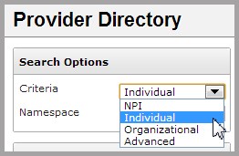

* The **NPI** (National Provider Identifier) option requires a 10-digit number from the [NPI Registry](https://npiregistry.cms.hhs.gov/NPPESRegistry/NPIRegistryHome.do) available from CMS.
* Selecting **Individual** searches for a clinician by name or location.
* Selecting **Organizational** searches for a hospital, clinic, or other organization by name or location.
* Selecting **Advanced** provides a number of additional search options, and allows search by **Individual** or **Organization** provider types.

To make a search more specific, you may choose **Combined**, **Local**, or **Global** from the *Namespace* drop-down. In most cases, you will use the Combined namespace filter. The Global namespace will search the Provider Directory for entries from the NPI Registry. The Local namespace searches for manual entries to your HIE’s Provider Directory.

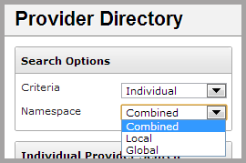

### Viewing a Provider

Once a provider is selected, the *Provider Detail* screen appears, showing the **View Provider** tab.

On this screen, information about the provider is divided into four sections:

* *Basic Provider Information*: includes basic demographics, contact information, and NPI information.

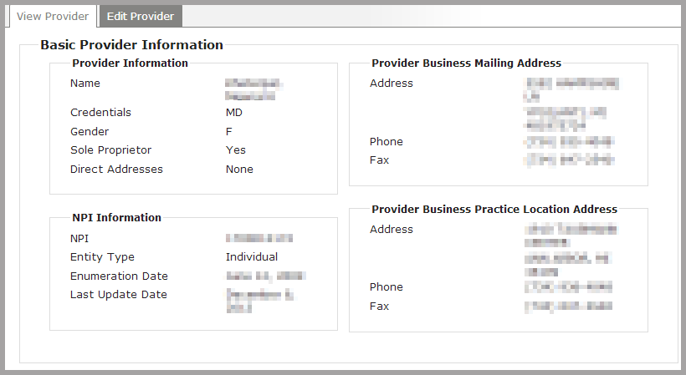

* *Provider Licenses*: includes information about specific medical licenses that the provider has been granted, the associated taxonomy code for each license.

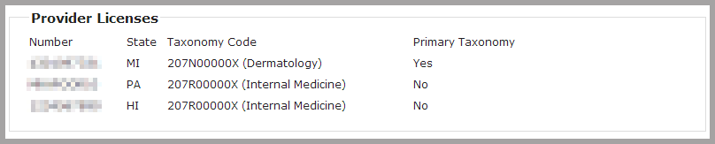

* *Other Provider Identifiers:* lists other sources of licenses or credentials.

Note: this section will not appear if other provider identifiers have not been added.



* *Data Sources*: specifies the primary source of the information displayed on the **View Provider** tab.

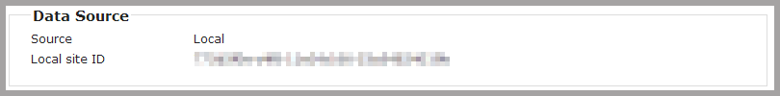

* *Other Sources*: lists any additional sources of information available for this provider.

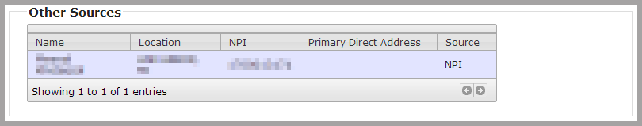

Note: other data sources can be viewed as the primary data source on the **View Provider** tab. To do so, click **expand** on theProvider Directory search results, and then choose a listed data source.

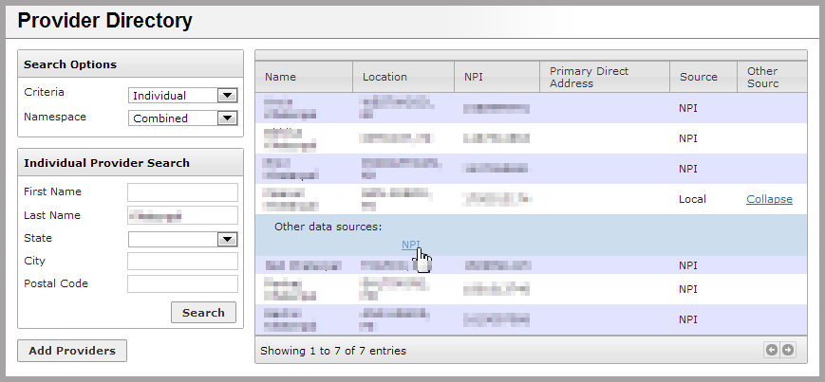

### Adding a Provider

To add a provider to the local Provider Directory, click the **Add Providers** button at the bottom of the *Provider Directory* search page. After clicking, enter a valid 10-digit NPI number in the appropriate box.

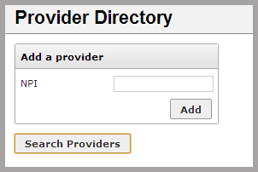

If the NPI number is already being used in the local directory, the message “NPI is already assigned” will appear. If the NPI number is not 10 digits long, the message “NPI must be a 10 digit number” will appear.

If the NPI number entered is 10 digits long and is not already being used the local directory, a new provider entry will be created.

### Direct Messaging in the Provider Directory

Direct Messaging uses the primary direct address associated with each provider to send Direct Messages. It can be accessed from the Application Dashboard or from the **Provider Directory** tab on the *Messaging* screen.



To begin, perform a provider search, and find the desired provider on the result list to the right.

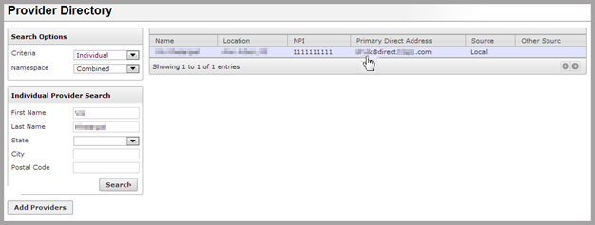

Clicking on the provider’s primary direct address takes you to the **Compose Message** screen, with the provider’s Direct Address auto-populated.